
FRESH TEACHER'S E-LIBRARY
BEGINNING OF TERM III EXAMINATION 2023
P.4 SOCIAL STUDIES & R.E
Time Allowed: 2hours 15 Minutes
Pupil’s Name: …………………………………..………………………
Class: ………………………………………………………………………
School Name: ………………………………………………………….
Read the following instructions carefully:
FOR EXAMINERS’

USE ONLY

Qn. No. | MARKS | EXR’S  No.
1 - 10
11 – 20
21 – 30
31 – 40
41 – 43
44 – 46
47 – 49
50 - 52
53 - 55
TOTAL

- This paper has two sections: A and B
- Section A has 40 questions (40 marks)
- Section B has 15 questions (50 marks)
- Answer all questions. All the working for both sections A and B must be shown in the spaces provided.
- All working must be done using a blue or blackball point pen or ink. Any work done in pencil will NOT be marked except drawings and diagram.
- Unnecessary changes in your work and handwriting that cannot be easily read may lead to loss of marks.
- Do not fill anything in the table indicated
Turn Over
“For examiners’ use only” and the boxes inside the question paper.

SECTION A : 40 MARKS
- Name the type of wood got from planted forests.
_____________________________________________________________
- What is a plateau?
_____________________________________________________________
- Give one way people care for social service centres in our
community.
_____________________________________________________________
- How is a clock useful in our class?
_____________________________________________________________
- Write one problem faced by people who live in valleys.
_____________________________________________________________
- Draw a map symbol of waterfalls in the space provided below.

- Give one cause of child abuse in our district.
_____________________________________________________________
- How was fire useful to the early man?
_____________________________________________________________
- State one way the police carry out its work in our community.
_____________________________________________________________
- Why do we need trees in our school compound?
____________________________________________________________
- Write one symbol of a clan.
_____________________________________________________________
- Give one way we keep our school clean.
_____________________________________________________________
- Which tribe in Uganda has the legend of Mundu and Sera?
_____________________________________________________________
- State one cause of domestic violence in our homes.
_____________________________________________________________
- What name is given to the special vehicle which is used to carry sick
people to hospital?

- Name the colour represented by letter P on the Uganda flag below.
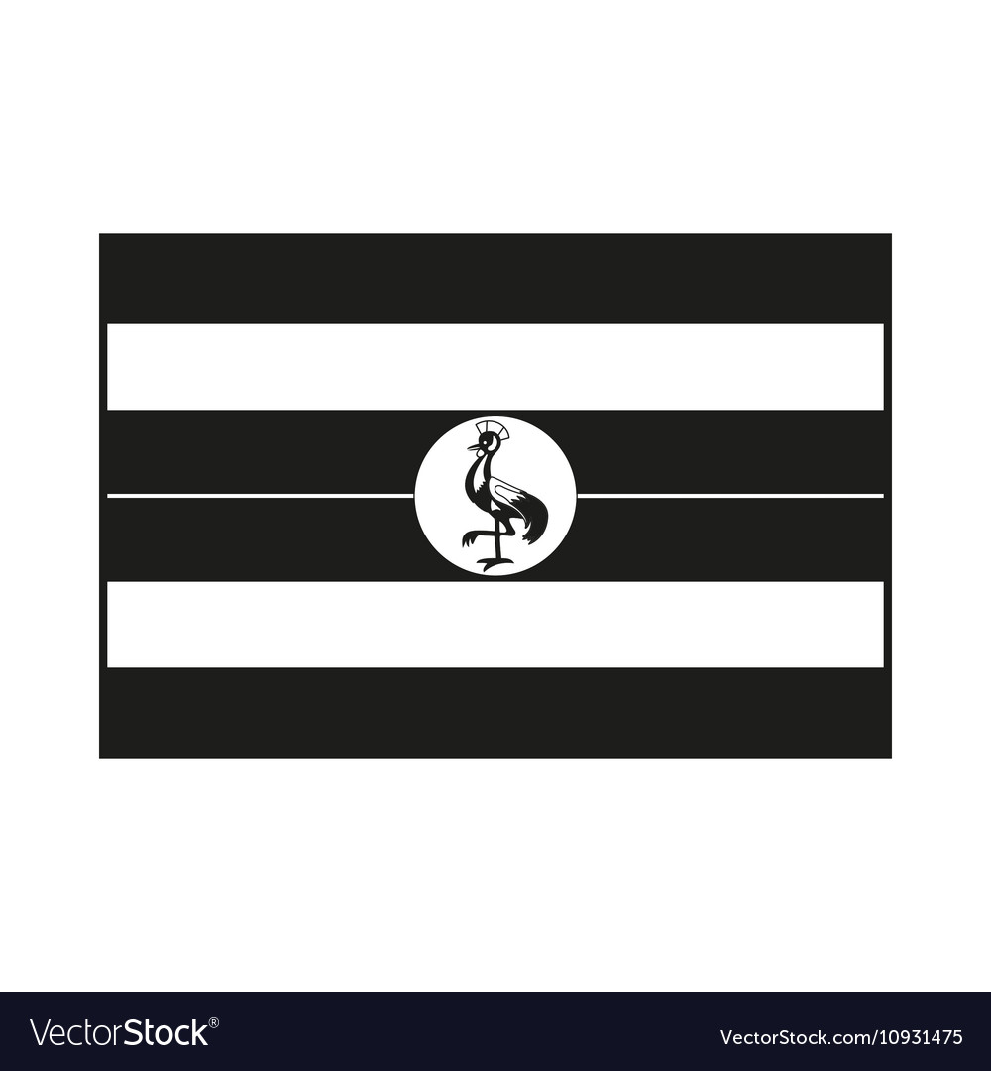
P
P________________________________

- Why does the government encourage people to grow crops?
_____________________________________________________________
- What lesson do you learn from the story of Gipiir and Labong?
_____________________________________________________________
- Name the body in Uganda that protects swamps.
_____________________________________________________________
- Give any one requirement needed before starting a project.
_____________________________________________________________
- How do we show respect to our National Anthem?
_____________________________________________________________
- Give one way of keeping security in a home.
_____________________________________________________________
- How is the traditional musical instrument below important in our
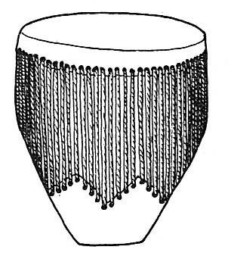
community?

_____________________________________________________________
- State one way of managing a rainy weather.
_____________________________________________________________
- How are banks important in our community?
_____________________________________________________________
- Write one way road accidents can be controlled in our district.
_____________________________________________________________
- Why do we switch off electricity when not in use?
_____________________________________________________________
- How is a school sign post important to our parents?
_____________________________________________________________
- Give one reason why some people fail to get their needs.

- Name the compass direction marked V.
N

V________________________________

V
- Which raw material is used to make clothes?
_____________________________________________________________
- Name the commonest cultural practice among the Bagisu.
_____________________________________________________________
- Write L.C in full.
_____________________________________________________________

- Mention one way of taking care of flowers in our school compound.
_____________________________________________________________
- Why do we need prefects in our school?
_____________________________________________________________
For questions 36 – 40, answer Either Christianity Or Islam but not both.
- Either: What is a prayer?
_____________________________________________________________
Or: What is Salat?
_____________________________________________________________
- Either: Why was Jesus taken to Egypt?
_____________________________________________________________
Or: Why did Prophet Muhammad move from Mecca to Medina?
_____________________________________________________________
- Either: Name any one son of Eve.
_____________________________________________________________
Or: Name any one son of Hawa.
_____________________________________________________________
- Either: How do Christians take care of the sick people?
_____________________________________________________________
Or: How do Muslims take care of the sick people?
_____________________________________________________________
- Either: Name the Christian symbol drawn below.
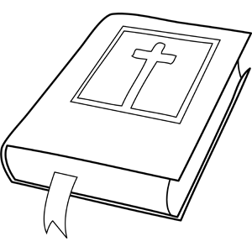
____________________________________________

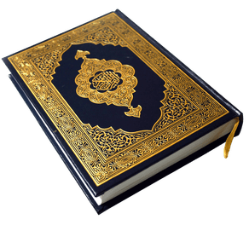
Or: Name the symbol of Islam drawn below.
___________________________________________

SECTION B
- (a) What is vegetation?
_________________________________________________________
(b) Mention any example of vegetation.
_________________________________________________________
(c) Give any one use of vegetation to people.
_________________________________________________________
(d) How do people care for vegetation in their compound?
________________________________________________________
- Study the weather instrument below and answer the questions that
R
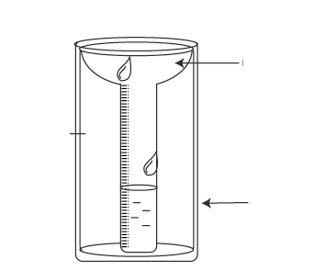
follow.

can

- Name the weather instrument drawn above.
_________________________________________________________
- What is the name of the part marked R?
_________________________________________________________
- Why is the above weather instrument important at a weather
station?
_________________________________________________________
- Give one reason why the above weather instrument is placed in
an open place / area.
_________________________________________________________
- (a) What are social activities?
_________________________________________________________
(b) Give the importance of social activities.
_________________________________________________________
(c) Mention any two examples of social activities in our district.
(i) _________________________________________________________
(ii) _________________________________________________________
- (a) Name the capital city of Uganda.
_________________________________________________________
(b) State one problem faced by people living in the capital city of
Uganda.
_________________________________________________________
(c) Give two reasons why Uganda is divided into districts.
(i) _________________________________________________________
(ii) _________________________________________________________
- (a) What is migration?
_________________________________________________________
(b) Name any one type of migration.
_________________________________________________________
(c) Give two reasons why people migrate from villages to towns.
(i) _________________________________________________________
(ii) _________________________________________________________
- (a) What term is used to mean things people cannot live without?
_________________________________________________________
(b) Give any two examples of things people cannot live without.
(i) ___________________________ (ii) _________________________
(c) Why do some people fail to meet their needs?
_________________________________________________________
- (a) Name the type of family which has a father, a mother and
biological children.
_________________________________________________________

(b) Write any two roles of a family head.
(i) _________________________________________________________
(ii) _________________________________________________________
(c) Why is it good to belong to a family?
_________________________________________________________
- (a) What are physical features?
_________________________________________________________
(b) Draw the map symbol for the following.
Mountain | Rift valley
(c) How are physical features important in our district?
_________________________________________________________

- The graph below shows the different cash crops grown by a group of people.

350
Numbers of people
Who grow crops
300
250
200
150
100
500
0
Tea
Palm oil
Coffee
Cotton
Sugarcane
Cash crops

- Which cash crop is grown by most people in the above area?
_________________________________________________________
- Name the crop grown by few people according to the graph.
_________________________________________________________
- Give one reason why people grow the above crops.
_________________________________________________________
- According to the graph, how many cash crops are grown in the
area above?
_________________________________________________________
- (a) Name the local material used to make balls.
_________________________________________________________
(b) Give two reasons why people make local materials.
(i) ________________________________________________________
(ii) _________________________________________________________
(c) Name the material used to make pots.
_________________________________________________________
For questions 51 to 55, answer either Christianity or Islam but not both.
- EITHER: (a) Give two ways Jesus showed love and care to people.
- _________________________________________________________
- _________________________________________________________
- As a Christian child, how can you show love and care to other
people?
_________________________________________________________
(c) How does a Christian child benefit by helping other children?
_________________________________________________________
OR: (a) Give two ways Prophet Muhammad showed love and care to
people.
- _________________________________________________________
- _________________________________________________________
(a) As a Muslim child, how can you show love and care to other
people?
_________________________________________________________
(b) What does a Muslim child benefit by helping other children?
_________________________________________________________
- EITHER: (a) What is worship?
_________________________________________________________
(b) Give one reason why people pray before leaving for a journey.
_________________________________________________________
(c) Mention two ways people worship God.
- _________________________________________________________
- _________________________________________________________
OR: (a) What is Salat?
_________________________________________________________
- Give one reason why Muslims pray before leaving for a journey.
_________________________________________________________
- Mention two ways Muslims pray to Allah.
- _________________________________________________________
- _________________________________________________________
- EITHER: Match list A with list B correctly.
List A List B
- Simon of cyrene doubted Jesus’ resurrection.
- Joseph of Arimathea betrayed Jesus.
- Judas Iscariot helped Jesus to carry the cross.
- Thomas buried the body of Jesus.
- Simon of cyrene ________________________________________
- Joseph of Arimathea _______________________________________
- Judas Iscariot ____________________________________________
- Thomas __________________________________________________
OR: Match list A with list B correctly.
List A List B
- Muhammad First wife of prophet Muhammad
- Aminah received Injil
- Isa perfected Islam
- Hadijah mother of prophet Muhammad
- Muhammad ______________________________________________
- Aminah __________________________________________________
- Isa ______________________________________________________
- Hadijah __________________________________________________
- EITHER: (a)Why are the following days remembered in Christianity?
- Christmas day _____________________________________________
- Pentacost ________________________________________________
- Good Friday ______________________________________________
- How do Christians prepare for a Christmas day?
_________________________________________________________
OR:
- Why are the following days remembered in Islam?
- Idd Elfitri _________________________________________________
- Idd Adhuha _______________________________________________
- Juma ____________________________________________________
- How do Muslims prepare for Idd Adhuha?
_________________________________________________________
- EITHER:
- Who is a leader in Christianity?
_________________________________________________________
- Give any two qualities of a good leader.
- _________________________________________________________
- _________________________________________________________
- Write any one leader in the church by title.
_________________________________________________________
OR: (a) Who is a leader in Islam?
_________________________________________________________
(b) Give any two qualities of a good leader.
- _________________________________________________________
- _________________________________________________________
(c) Write any one leader in the mosque by title.
_________________________________________________________
***************END******************

